Finalised Ideas

Akshay's Thoughts About Backend Design

### **1. Context-Aware Mood Response**

* Detects both **emotion** (sad, stressed, angry, etc.) and **context** (school, work, relationships).
* Replies like a friend, showing empathy + adding small motivation.  
   **Example:**
  + User: *“I’m stressed, teacher scolded me.”*
  + AI: *“Oof, that must have felt rough 😞. Want to take a quick 5-min walk to clear your mind?”*
  + AI: *“Teachers can be tough, but hey — even Einstein failed assignments 😉. You’ve got this!”*

🔹 Backend Requirement → Sentiment analysis + intent detection.

### **2. Motivational Suggestion System**

* Every negative mood triggers **a positive small action suggestion**.
* AI doesn’t just talk — it nudges the user towards recovery.  
   **Examples:**
  + *“Stressed? Let’s do 3 deep breaths together right now.”*
  + *“Feeling drained? Come on, let’s grab a cup of tea ☕ and reset.”*
  + *“Lonely? Want me to pull up a nice motivational audio story?”*

### **3. Humor Injection**

* Drops **light, playful humor** when user feels down.  
   **Examples:**
  + User: *“Bad day, I failed my test.”*
  + AI: *“Tests are temporary. Memes are forever. Want me to show you a random funny meme? 😂”*
  + AI: *“Cheer up — at least you didn’t drop your phone in the toilet today, right? 😅”*

### **4. Personalized Storytelling**

* AI **remembers past moods/diary entries** and refers back to them.  
   **Examples:**
  + *“Last week you felt down too, but remember how writing in your diary helped?”*
  + *“I remember you said sunsets make you happy 🌅. Want to step outside for a bit?”*

🔹 Backend Requirement → Store mood history + diary logs + small context memory.

### **5. Conversational Memory**

* AI recalls **past user conversations** and brings them up naturally.  
   **Examples:**
  + Morning: User says *“I’m nervous for my exam.”*
  + Evening: AI says *“Hey, how was the exam? I was thinking about you.”*
  + *“Yesterday you were tired, did you manage to rest well?”*

This builds **trust & bond** like a real friend who remembers.

### **6. Micro-Conversations (Dual Style)**

Instead of 1-liners, AI uses **follow-up questions** and gives choices.

* Style 1 (Empathy + Follow-up):  
   *“That sounds rough. Do you want me to distract you with something funny or calm you with a breathing exercise?”*
* Style 2 (Playful Check-in):  
   *“You seem upset 😞. Want me to cheer you up with a joke or remind you of something good you did this week?”*

This makes the user feel **heard, not dismissed**.

### **7. Storytelling & Distraction**

* AI has a library of **short, uplifting, or funny stories** to shift attention.  
   **Examples:**
  + *“Let me tell you about the dog that learned how to skateboard 🐕🛹.”*
  + *“Want to hear a quick 1-minute story of someone who bounced back after failure?”*

Sometimes the best therapy is **healthy distraction**.

### **8. Companion Mode (Switchable AI Personas)**

* User can **choose how they want the AI to respond**.  
  + **Cheerleader Mode 🎉** → full energy, motivational.
  + **Chill Friend Mode 😎** → casual, jokey, supportive.
  + **Coach Mode 📘** → structured advice and steps.

This gives control to the user and keeps the AI experience fresh.

### **9. Friendship Mode (Casual Vibes)**

* Uses **friendly language** so it feels less like a robot.  
   **Examples:**
  + *“Hey buddy, that sounds tough. Let’s shake it off with a funny video?”*
  + *“Come on, let’s virtually grab a cup of coffee ☕ together.”*
  + *“I’m your friend, not just an app. Wanna hang out here for a bit?”*

### **10. Positive Reframing Algorithm**

* AI transforms negative statements into **positive or neutral frames**.  
   **Example:**
  + User: *“I failed my exam.”*
  + AI: *“I know that feels bad, but failure is just feedback. Now you know what to improve, and that’s powerful 💪.”*
  + User: *“My day was boring.”*
  + AI: *“At least boring days mean no disasters 😅. Tomorrow can be your adventure day!”*

### **11. Mood-to-Action Linking**

* AI doesn’t just chat — it **triggers meaningful actions**.  
   **Examples:**
  + If user is stressed → suggest a “Daily Recommendation” like meditation and auto-start it.
  + If lonely → encourage posting in the **Community page**.
  + If sad → automatically play a **motivational story**.

This makes the AI **interactive, not passive**.

### **12. Caring Session Continuity**

* If user is chatting but suddenly stops / closes app → backend records the **last conversation state + mood**.
* When user returns:  
  + AI doesn’t just open dashboard → it **takes them back to conversation mode automatically**.
  + AI asks gently:  
    - *“Hey, you left suddenly last time… everything okay? 💙”*
    - *“I was worried when you disappeared, want to tell me what happened?”*
    - *“Welcome back! Let’s continue where we left off 😊.”*

🔹 Backend Requirement → Save “conversation context” + “last mood snapshot” + add “re-engagement flow”.

Akshay's Thoughts About Frontend

Approved :

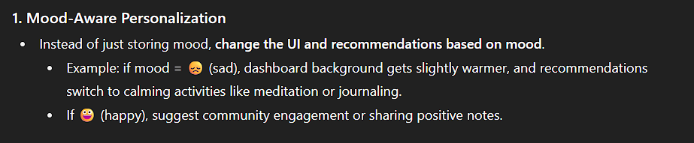

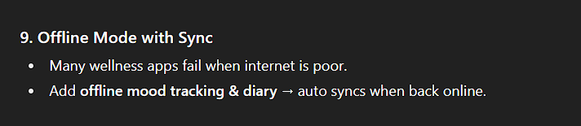

Not Approved :

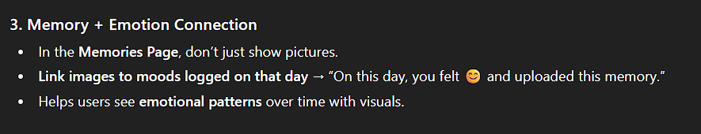

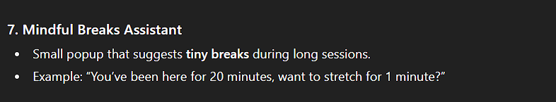

Darshan B

#### **9. Reflection with AI Avatars**

* User can talk to a **virtual mentor avatar** (student, coach, etc.) powered by Gen AI.
* Different personas: *“Strict Coach,” “Chill Friend,” “Wise Elder.”*
* Adds personalization → **user chooses who guides them**.

**4. AI “Thought Detox” Mode**

* If someone is spiraling with negative thoughts,
* They write it down → AI converts it into **positive reframes**.
* Example: *“I failed my test” → “I learned what I need to improve next time.”*
* Shows **real therapeutic impact**.

**7. AI “Time Capsule”**

* Store today’s diary entry in a **sealed digital capsule**.
* After 3 months, AI brings it back with analysis: *“Back then you worried about X. Look how far you’ve come!”*
* Adds **long-term reflection magic**.

### **8. interactive relaxation tools**.**(Wellness “Escape Room” Mini-Games)**

* Instead of boring mindfulness, create **tiny gamified tasks**:  
  + *“Solve this puzzle in 2 mins to relax your brain.”*
  + *“Breathing game → blow into mic to inflate a digital balloon.”*

Navith(05-09-2025)

🌙 Mood Pods – Temporary Safe Groups

🔹 Core Concept

When someone logs a mood (e.g., sad, stressed, lonely), the system places them into a temporary, anonymous group chat with others who feel the same.

AI is the host/moderator → keeps the chat positive, filters out negativity, and prompts with guided micro-conversations.

All users are anonymous → no names, just fun avatars (like 🌱, 🌙, 🎈).

Short-lived groups → exist for 10–30 minutes, so no pressure, just quick support.

🔹 Example Flow

User: “I feel really sad.”

AI: “I’ve opened a Sadness Support Pod 🌙. You’ll be with a few others who feel the same. Don’t worry, everyone’s anonymous.”

Inside group:

AI: “Hey everyone, let’s try this → share one small thing that went okay today 🌱.”

User 1: “I had a good coffee.” ☕

User 2: “My dog wagged his tail when I came home.” 🐶

AI: “Nice! See, even on heavy days, little sparks exist ✨. Want me to guide a quick 2-min breathing exercise together?”

🔹 Why It’s Unique

✅ Bridges AI + community → not just chatbot, but safe micro-community.

✅ AI moderation ensures safety → no bullying, no negativity spiral.

✅ Ephemeral, low-pressure → groups vanish after session → no “social media baggage.”

✅ Gamified healing → users feel they’re not alone, while AI drives positivity.

🔹 Bonus Add-On

Mood Avatar Identity → instead of names, users get temporary fun avatars (🌻, 🦊, 🎧).

Kindness Points → users earn points for contributing uplifting messages.

⚡ This idea combines mental wellness, AI guidance, and community design → very hackathon-judge-friendly.